Prototype Documentation

# Group details

|  |  |
| --- | --- |
| Group number |  |
| Member names and UPIs |  |
| Group name |  |
| System name |  |

# UC#1

UC#1 name: …

## UC#1 Functionality

### F#X

*<Screenshots where function F#X is performed in (either) prototype>*

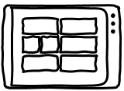 

### F#Y

*<Screenshots where function F#Y is performed in (either) prototype>*

  

### F#Z

…

## UC#1 Data

*<Identify entities and attributes in list form (or any tidy format); add/remove columns/rows as needed>*

|  |  |  |
| --- | --- | --- |
| Entity name: | Entity name: | Entity name: |
| Attributes:   * x * y * z | Attributes:   * x * y * z | Attributes:   * … |

*<Annotated screenshots where the above entity/entities and attributes is/are seen in (either) prototype>*



## UC#1 Demonstration/simulation

Chosen function number: F#

Chosen function name: …

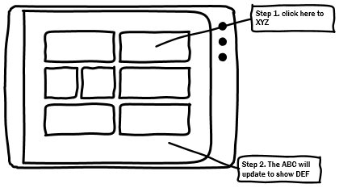

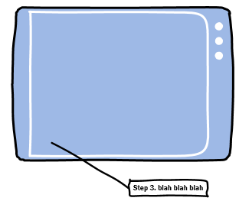

## F# Test plan

|  |  |
| --- | --- |
| Goal/Description of test plan | *<What does this test plan aim to achieve?>* |
| Testing method | *<Explain how this function will be tested on the prototype; be specific>* |
| Expected successful result | *<Explain the expected outcome or behaviour when the testing method is successfully performed>* |
| Other notes (optional) | *<Write any notes the marker should know which do not fit within the above headings>* |

# UC#2

UC#2 name: …

## UC#2 Functionality

### F#X

*<Screenshots where function F#X is performed in (either) prototype>*

 

### F#Y

*<Screenshots where function F#Y is performed in (either) prototype>*

  

### F#Z

…

## UC#2 Data

*<Identify entities and attributes in list form (or any tidy format); add/remove columns/rows as needed>*

|  |  |  |
| --- | --- | --- |
| Entity name: | Entity name: | Entity name: |
| Attributes:   * x * y * z | Attributes:   * x * y * z | Attributes:   * … |

*<Annotated screenshots where the above entity/entities and attributes is/are seen in (either) prototype>*



## UC#2 Demonstration/simulation

Chosen function number: F#

Chosen function name: …





## F# Test plan

|  |  |
| --- | --- |
| Goal/Description of test plan | *<What does this test plan aim to achieve?>* |
| Testing method | *<Explain how this function will be tested on the prototype; be specific>* |
| Expected successful result | *<Explain the expected outcome or behaviour when the testing method is successfully performed>* |
| Other notes (optional) | *<Write any notes the marker should know which do not fit within the above headings>* |

# UC#3

UC#3 name: …

## UC#3 Functionality

### F#X

*<Screenshots where function F#X is performed in (either) prototype>*

 

### F#Y

*<Screenshots where function F#Y is performed in (either) prototype>*

  

### F#Z

…

## UC#3 Data

*<Identify entities and attributes in list form (or any tidy format); add/remove columns/rows as needed>*

|  |  |  |
| --- | --- | --- |
| Entity name: | Entity name: | Entity name: |
| Attributes:   * x * y * z | Attributes:   * x * y * z | Attributes:   * … |

*<Annotated screenshots where the above entity/entities and attributes is/are seen in (either) prototype>*



## UC#3 Demonstration/simulation

Chosen function number: F#

Chosen function name: …





## F# Test plan

|  |  |
| --- | --- |
| Goal/Description of test plan | *<What does this test plan aim to achieve?>* |
| Testing method | *<Explain how this function will be tested on the prototype; be specific>* |
| Expected successful result | *<Explain the expected outcome or behaviour when the testing method is successfully performed>* |
| Other notes (optional) | *<Write any notes the marker should know which do not fit within the above headings>* |

# UC#4

UC#4 name: …

## UC#4 Functionality

### F#X

*<Screenshots where function F#X is performed in (either) prototype>*

 

### F#Y

*<Screenshots where function F#Y is performed in (either) prototype>*

  

### F#Z

…

## UC#4 Data

*<Identify entities and attributes in list form (or any tidy format); add/remove columns/rows as needed>*

|  |  |  |
| --- | --- | --- |
| Entity name: | Entity name: | Entity name: |
| Attributes:   * x * y * z | Attributes:   * x * y * z | Attributes:   * … |

*<Annotated screenshots where the above entity/entities and attributes is/are seen in (either) prototype>*



## UC#4 Demonstration/simulation

Chosen function number: F#

Chosen function name: …





## F# Test plan

|  |  |
| --- | --- |
| Goal/Description of test plan | *<What does this test plan aim to achieve?>* |
| Testing method | *<Explain how this function will be tested on the prototype; be specific>* |
| Expected successful result | *<Explain the expected outcome or behaviour when the testing method is successfully performed>* |
| Other notes (optional) | *<Write any notes the marker should know which do not fit within the above headings>* |

# UC#5

UC#5 name: …

## UC#5 Functionality

### F#X

*<Screenshots where function F#X is performed in (either) prototype>*

 

### F#Y

*<Screenshots where function F#Y is performed in (either) prototype>*

  

### F#Z

…

## UC#5 Data

*<Identify entities and attributes in list form (or any tidy format); add/remove columns/rows as needed>*

|  |  |  |
| --- | --- | --- |
| Entity name: | Entity name: | Entity name: |
| Attributes:   * x * y * z | Attributes:   * x * y * z | Attributes:   * … |

*<Annotated screenshots where the above entity/entities and attributes is/are seen in (either) prototype>*



## UC#5 Demonstration/simulation

Chosen function number: F#

Chosen function name: …





## F# Test plan

|  |  |
| --- | --- |
| Goal/Description of test plan | *<What does this test plan aim to achieve?>* |
| Testing method | *<Explain how this function will be tested on the prototype; be specific>* |
| Expected successful result | *<Explain the expected outcome or behaviour when the testing method is successfully performed>* |
| Other notes (optional) | *<Write any notes the marker should know which do not fit within the above headings>* |

# Design principles

## 1. User in control

*<Brief explanation and screenshot (with annotations if necessary)>*

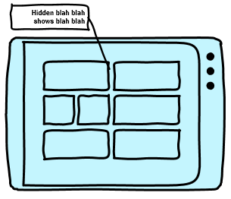

### 2. Directness

*<Brief explanation and screenshot (with annotations if necessary)>*

### 3. Consistency

*<Brief explanation and screenshot (with annotations if necessary)>*

### 4. Forgiveness

*<Brief explanation and screenshot (with annotations if necessary)>*

### 5. Feedback

*<Brief explanation and screenshot (with annotations if necessary)>*

### 6. Aesthetics

*<Brief explanation and screenshot (with annotations if necessary)>*

### 7. Simplicity

*<Brief explanation and screenshot (with annotations if necessary)>*

# Appendix: Progress reports

*<Append your progress reports to the end of this document.>*